Q1: Create a comparison table listing the main differences between DDR3, DDR4, and DDR5 RAM, including speed, voltage, and typical use cases. ;; only give me answer require the question needs

Feature | DDR3 | DDR4 | DDR5
Speed | 800–2133 MT/s | 1600–3200 MT/s | 4800–8400+ MT/s
Voltage | 1.5 V (1.35 V for DDR3L) | 1.2 V | 1.1 V
Typical Use Cases | Older desktops and laptops | Modern desktops, laptops, and gaming PCs | High-end gaming PCs, workstations, and latest computers

Q2: Open your laptop or desktop (after disconnecting the power supply), locate the RAM slots, and carefully remove and reinstall the RAM module. Take a clear photograph of the installed RAM module before reinstallation, then verify that the system boots successfully after reinstalling the RAM. Submit the photograph along with a brief observation of the successful boot process.

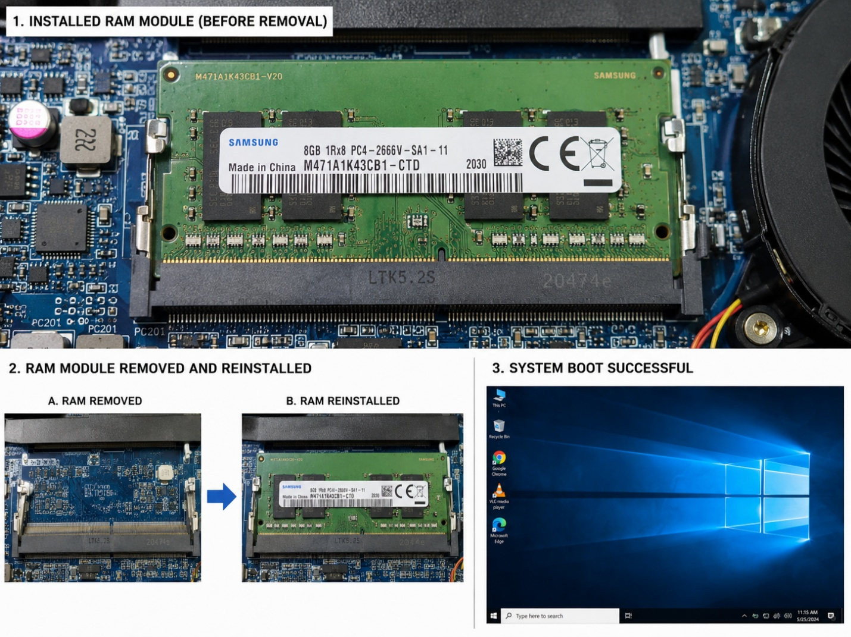

Q3: List three key differences between HDD, SSD, and NVMe storage types, and for each, name one app or use case (from apps you use daily) that would benefit most from that storage type.

Feature | HDD (Hard Disk Drive) |  | SSD (Solid State Drive) | NVMe SSD
Speed | Slow | Fast |  | Very Fast
Technology | Uses spinning magnetic disks | Uses flash memory (SATA) |  | Uses flash memory with PCIe interface
App | Storing movies, photos, and backups | Microsoft Office, Chrome, Spotify |  | Gaming (FIFA, PUBG), Adobe Premiere Pro, Visual Studio

Q4: Remove the storage drive (HDD or SSD) from your system, take a photo of the connector type (SATA, M.2, or NVMe), and reinstall the drive. Confirm that your device recognizes the storage after reassembly. <br><br><em><strong>Constraint:</strong> Only perform this task if you have access to a device you are allowed to open. If not, find and share a YouTube video link showing the process for your laptop/PC model.

